Week in Review - March 2-8
Alex Shvartsman

JUST SAY NO TO COMBO
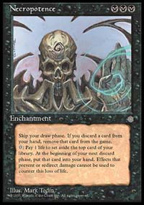
So long, Skull!
The new Banned and Restricted list update has been released, with some major changes in the Extended format. As of April 1st, Necropotence, Replenish, Demonic Consultation, and Survival of the Fittest are banned in that format.
Necropotence and Replenish proved too powerful as card advantage engines, when used to help set up combos. They were especially prominent in Trix and Blackjack decks, the presence of which were felt strongly during the last Extended PTQ Season. Similarly, Demonic Consultation was a little too helpful in setting up various combos quickly.
Survival of the Fittest does not help any combo deck win on turn 4. However, with the other three cards removed from the format, decks powered by Survival would become virtually unstoppable. They were clearly good enough even with Necro in the format, as Trade-Survival variant won the first Masters Series tournament in NY. Of course, the *real* reason for banning Survival may be the fact that an average level 2 judge could not handle the seven-rulings-per-turn Full English Breakfast deck, designed by rules guru Paul Barclay.

FREQUENT PLAYER MILES
Legend membership DCI program has been canceled to make room for something new - a reward program that will award players with promotional cards, such as a foil Wasteland - based on the number of sanctioned tournaments they participate in.
Check out the announcement regarding this new program, and stay tuned for more details to be announced shortly.

COMING UP: GP RIO DE JANEIRO AND PRAGUE
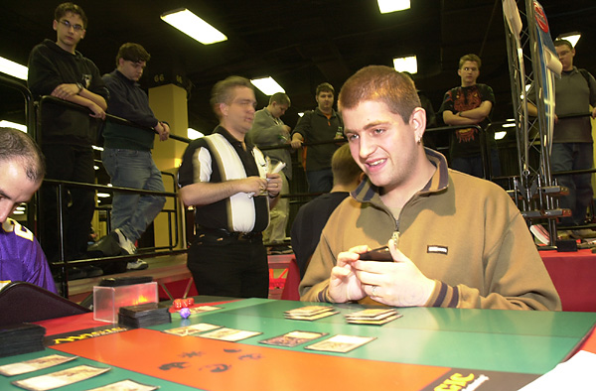
Top Czech player, Jakub Slemr
Still recovering from the Carnival, Rio de Janeiro will be hosting its second Grand Prix. The first one coincided with the Magic Invitational in 1997, and was wildly successful. GP circuit returned to Brazil last season, when the first major tournament to feature Mercadian Masques was held in Sao Paulo. This event revisits Rio, one of world's most attractive tourist destinations, and many players will travel across South and Central America to attend.
The GP circuit will visit Prague, capital of the Czech Republic, for the first time. Many of the top European players will make the trip despite the looming Pro Tour. Kai Budde is going to be there. It is unclear whether Kamiel Cornelissen will show up to try and close the gap between him and Mike Pustilnik in the standings. Pustilnik, as most American players, will spend the weekend at home, getting ready for the PT. A few Americans will travel to Rio despite having to go straight from there to Tokyo. Among them are Steve OMS, Dave Williams, James Stroud, and yours truly.

PLAYTESTING FOR TOKYO

Everyone wondered what group Brian Kibler and Ben Rubin would end up testing with. It seems they've resurrected The Jumble, working with their online friends. Reportedly, Jon Finkel, Dan OMS, Steve OMS, William Jensen, Matt Linde, Brock Parker, and Peter Szigeti are all part of this testing group.


ART FOR SEVENTH EDITION
Seventh Edition is not very far away, and Wizards of the Coast is slowly releasing the set's all-new artwork, for all those interested, at www.wizards.com/magic/advanced/7e/7e_artpreview.asp. You won't know which card is which, but it's fun to try and guess.

MAGIC TRIVIA
Last week's question:
How many Scryb Sprites does it take to kill a first-striking Sengir Vampire in combat?
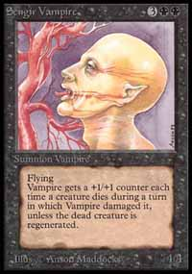
Scryb Sprites are tasty.
This question was actually on the very first judge test ever produced. You need a total of twelve Scryb Sprites. Here is how this goes down: Sengir Vampire deals the first strike damage, taking out four Sprites and growing to 8/8. Then regular damage is allowed to resolve, so you need a tag-team of twelve Sprites to take out the evil vampire. The real question on the judge test should have been in regard to how did anyone sneak twelve Scryb Sprites into play?
New questions:
What is the only red card that allows its caster to gain life?
Name a card that features an actual historical figure in its artwork?
Please do not e-mail me with your answers. There is no prize, this is strictly for fun. Correct answer will be posted in the next week's column.

BEST OF THE NET

Humor is a lot more difficult to write than strategy - so very few authors try. Among those who do, Tony Boydell is quite distinguished. His sense of humor is quite unique (though also clearly British). Tony writes a regular column for CCGPrime.com, and publishes articles on Star City. Take a look at his latest offering, titled "Lounge Act".

YOUR MANA'S WORTH
Here is a quote from last week's Play of the Week: "the Sliver player didn't block, thinking he was safe from lethal damage. Chris did the normal trick, Survivaling for Hellion, activating it 10 times, then in response Survivaling for Phyrexian Dreadnought, placing 20+ points of damage on the stack. This is where it gets good; once damage was on the stack Chris used a Quirion Range to untap the Shifter/Nought, Survivaled for an Elvish Lyrist, and sacced the Shifter/Lyrist(still hasted because of the Hellion ability) to detroy the Worship."
If you think that play works, your rules knowledge is as bad as, well, mine. Here is an explanation of why it doesn't, from DCI Netrep Michael Mason:
"When the Chris puts the Elvish Lyrist into the graveyard as part of activating the Survival of the Fittest, the survival effect will go on the stack, and then *before* any player gets the chance to activate an ability (i.e., the Lyrists') state based effects are checked and the Shifter/Lyrist is put into the graveyard because its toughness is zero, due to the previously resolved Hellion activations.
So while the play of the week looked good on the fly, it falls apart when the details are examined and probably floats to the "worst play of the week" since Chris just wasted four valuable resources on a plan which was destined to fail from the outset."
Sorry about the confusion. I will attempt to screen the plays for accuracy/legality more carefully in the future. Thanks to everyone who wrote in to let me know about the error.

BAD PLAY OF THE WEEK
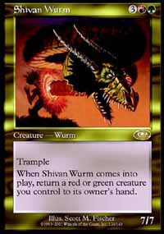
Two very similar misplays this week:
"I drafted a blue/black deck and in my third booster opened a Shivan Wurm. I thought it was so powerful I would splash it in as the only non-blue/black card. When I started playing, I realized it was useless, and that the Forests and Mountains I put in were colorless mana. Luckily, it was only a fun game with my brother and cousin."
from Gary Oliver, embarrassed Englishman

And:
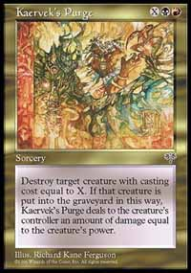
I was playing an Italian Mirage/Visions/Legends sealed deck side event. My colors were G/B/r. It was round 2 and I had just lost game 1. I decided to sideboard out black in favor of white.
At some point during game 2, I surprised myself by drawing a 'Kaervek's Purge', a red/black gold spell. Apparently I forgot to sideboard it out after game 1 along with the mono-black cards. I was upset about such a stupid mistake, especially since the game wasn't going very well for me anyway.
A few turns later, I surprised myself once again, this time by drawing a Swamp! Apparently I also forgot to remove that lone Swamp. So I cast the Kaervek's Purge. Unfortunately, I lost the game anyway.
Rainer Plaumann
Team Deflection
As always, please send good/bad plays, cool trivia questions, and other news to ashv@concentric.net.
I would like to apologize to everyone in advance, but I won't be able to reply to any e-mail until March 19 because of an extended trip. If you e-mail me, please expect a reply after that date.

